Game Design Document

Fill up the following document

1. Write the title of your project.

Girl runner

1. What is the goal of the game?

The goal of the game is the girl have to run fom the witch

1. Write a brief story of your game.

In this game we will see a girl running from a witch , There was a girl

Who was searching for some food because she was so hungry then she saw a jungle when she enters in jungle she saw there was some food which was thrown on the ground when she completed eating that food she saw someone who was watching her from back,when she goes near to that person she saw a witch who was so angry because girl has eaten her food and witch started going near to the girl and girl started running and is witch also stated running behind her to kill her.

1. Which are the playing characters of this game?

* Playing characters are the ones who respond to the user based on the input from the user.
* Cars, monkeys, dinos, wizards, etc., are the playing characters in the game.

|  |  |  |
| --- | --- | --- |
| Number | Character Name | What can this character do? |
| 1 | girl | Gir can run in tthis game to save herself from the witch |
| 2 |  |  |
| 3 |  |  |
| 4 |  |  |
| 5 |  |  |
| 6 |  |  |
| 7 |  |  |
| 8 |  |  |

1. Which are the Non-Playing Characters of this game?

* Non-Playing characters are the ones that don't have an action or behavior when the user interacts with the game.
* Hurdles, stones, bananas, coins, etc., are non-playing characters in the game.

|  |  |  |
| --- | --- | --- |
| Number | Character Name | What can this character do? |
| 1 | witch | She will run behind the girl to kill her |
| 2 |  |  |
| 3 |  |  |
| 4 |  |  |
| 5 |  |  |
| 6 |  |  |
| 7 |  |  |
| 8 |  |  |

Draw your imagination of this game. What does this game look like?

* Draw the game either on your computer or on paper.
* Add images of the game scenes to show each of the playing and non-playing characters at least once.

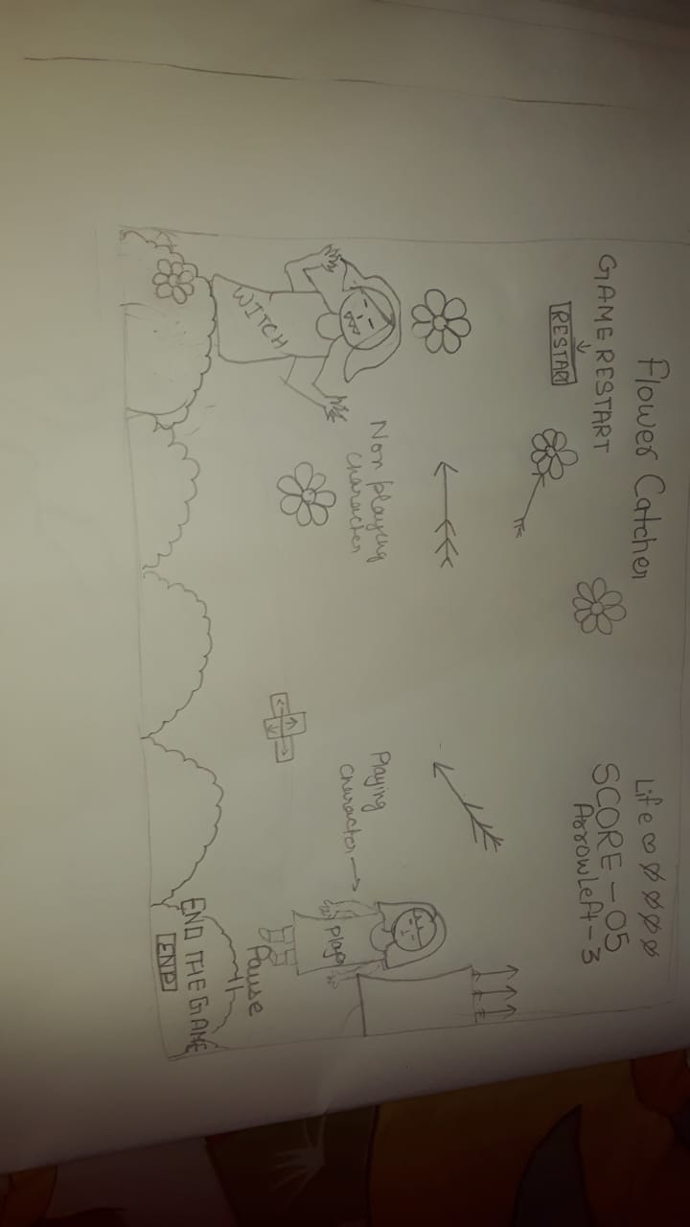

How do you plan to make your game engaging?

adding sound, adding score,addind moving background